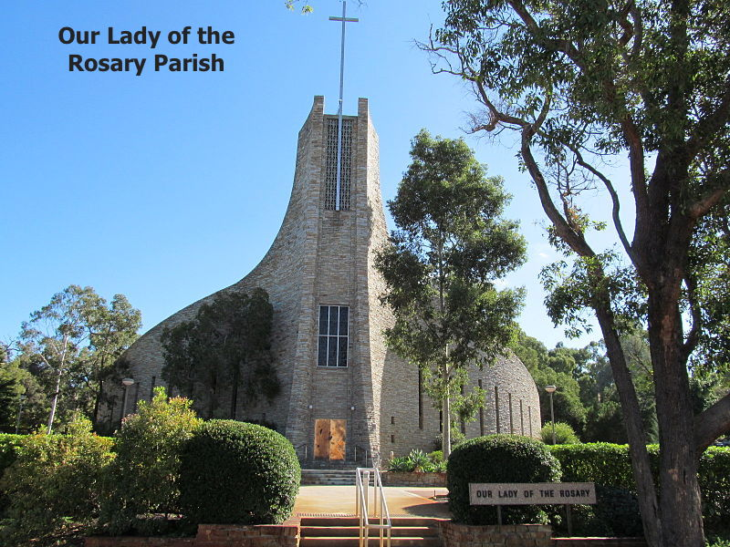

SACRAMENTAL ENROLMENT INFORMATION
OUR LADY OF THE ROSARY PARISH
17 Angelico St.
Woodlands WA 6018
Ph: 0411123441

CANDIDATES NAME: (please print)…………………………………………………….…………………

EMAIL ADDRESS: ……………………………………………………………………..…………….……….

PHONE NUMBER: …………………………………………………………………….………………………

SCHOOL: ……………………………………………………………………………….……………………..

DATE OF BIRTH: …………………………………………..…. MALE/FEMALE…………………………….

BAPTISM DATE: ……………………………………………..

PARISH OF BAPTISM: (full address)………………………….…………………………………………….

…………………………………………………………………………………………………………..………

SACRAMENT REQUIRED for this year (please tick)

Reconciliation
Eucharist
Confirmation

Doubleview Parish adheres to the Privacy Act, 1988, as amended and the Privacy (Amendments) Act, 2000. The purpose of the information being collected is to enable the administration and recording of the Sacraments and further pastoral support. In some cases the information is required to be passed on to the Parish of baptism or residence. To view or obtain a copy of our Privacy Policy or to seek access to personal information, please contact the Parish office, 17 Angelico St Woodlands, WA 6018 Ph. 9446 2055.

CANDIDATE’S COMMITMENT

As a candidate, I will try my best to prepare well for this Sacrament, I will actively take part in all lessons and liturgies and I will ensure all work is completed. I will talk with my parents and teachers about my faith.

Signed: ……………………………………………………………………..

PARENT’S COMMITMENT

As a parent, I understand that I can best
support my child in this Sacrament preparation by ensuring their regular attendance at Mass and classes and by my attendance at Sacrament parent meetings when required. I will talk with my child about this
Sacrament.

Signed: …………………………………………………………………….

